**New Special School for pupils with autism - Consultation Proposal**

There has also been significant growth in Newcastle’s school age population in recent years, including the numbers of pupils with special educational needs and/or disabilities (SEND) due to general population growth and increased incidence, especially of autism.

The needs of the vast majority of SEND children and young people are met in their mainstream setting and the proportion of children and young people with Education, Health and Care Plans (EHCP) being educated in mainstream schools has increased over time to 60% in 2022/23.  
  
All special schools in Newcastle have expanded in recent years to address the increased need for specialist places, especially Thomas Bewick which is our special school for pupils with autism. In January 2013, there were 102 pupils aged 4-19 years on roll at Thomas Bewick, which had increased to 314 pupils on roll in January 2023. A further expansion is currently taking place to provide additional places for September 2024.  
  
Our **SEND Strategy 2023-28**, published in September 2023, sets out our shared ambition which is:

‘to create an inclusive city that ensures that children and young people with SEND get the right support at the right time and go on to live their best lives’.

One of the key actions in the strategy is to ensure that there are sufficient specialist places for those that need them, including the development of a new school for those with autism.  
  
**Proposal – the new school**  
We propose to establish a new school, which will have capacity for 192 children and young people aged 4 -16 years with a range of abilities and differences associated with autism. All of the pupils will have an EHC plan and a primary need of autism.  
  
When established, via the **DfE free school presumption process**, the new school will be an academy. The presumption process will determine which multi-academy trust will be appointed to run the new school.  
  
The proposed site of the new school is Allendale Road (NE6 2SZ), a brownfield site to the east of the centre of the city which is owned by the City Council. The site has been chosen because it is council-owned, of sufficient size, and well connected in terms of accessibility to public transport and road networks. Its location, East of the city centre in Byker ward, is on the opposite side of the city to Thomas Bewick, so would enable more children with additional needs to be educated in or closer to the area where they live and spend less time travelling to and from school.

**Consultation process**

A consultation was carried out between 6 February 2024 and 13 March 2024 to seek stakeholder feedback on the proposed new school, age range and site.

The consultation documents and feedback form were published on Newcastle’s Schools portal and Council website – local offer, Let’s Talk and a wide range of different stakeholders were informed about the consultation and encouraged to respond.

Consultees included:

* Cabinet and Local Councillors
* Newcastle schools and academies - Headteachers, Governors, SEND Co-ordinators
* Academy Trust CEOs
* SEND Exec Board and partners
* Health partners
* Newcastle City Council managers and staff
* Circulate to SEND sub- group and Promise Board
* Early years providers
* Post-16 providers
* Parents and carers
* Diocesan Directors
* Neighbouring local authorities
* MPs
* Voluntary and community sector organisations
* DfE

# Stakeholder Consultation Feedback

A total of 226 responses were received and a summary of the feedback has been collated below.

# Who responded? (Q7)

# Respondents were asked to select which of the following best reflects who they are:

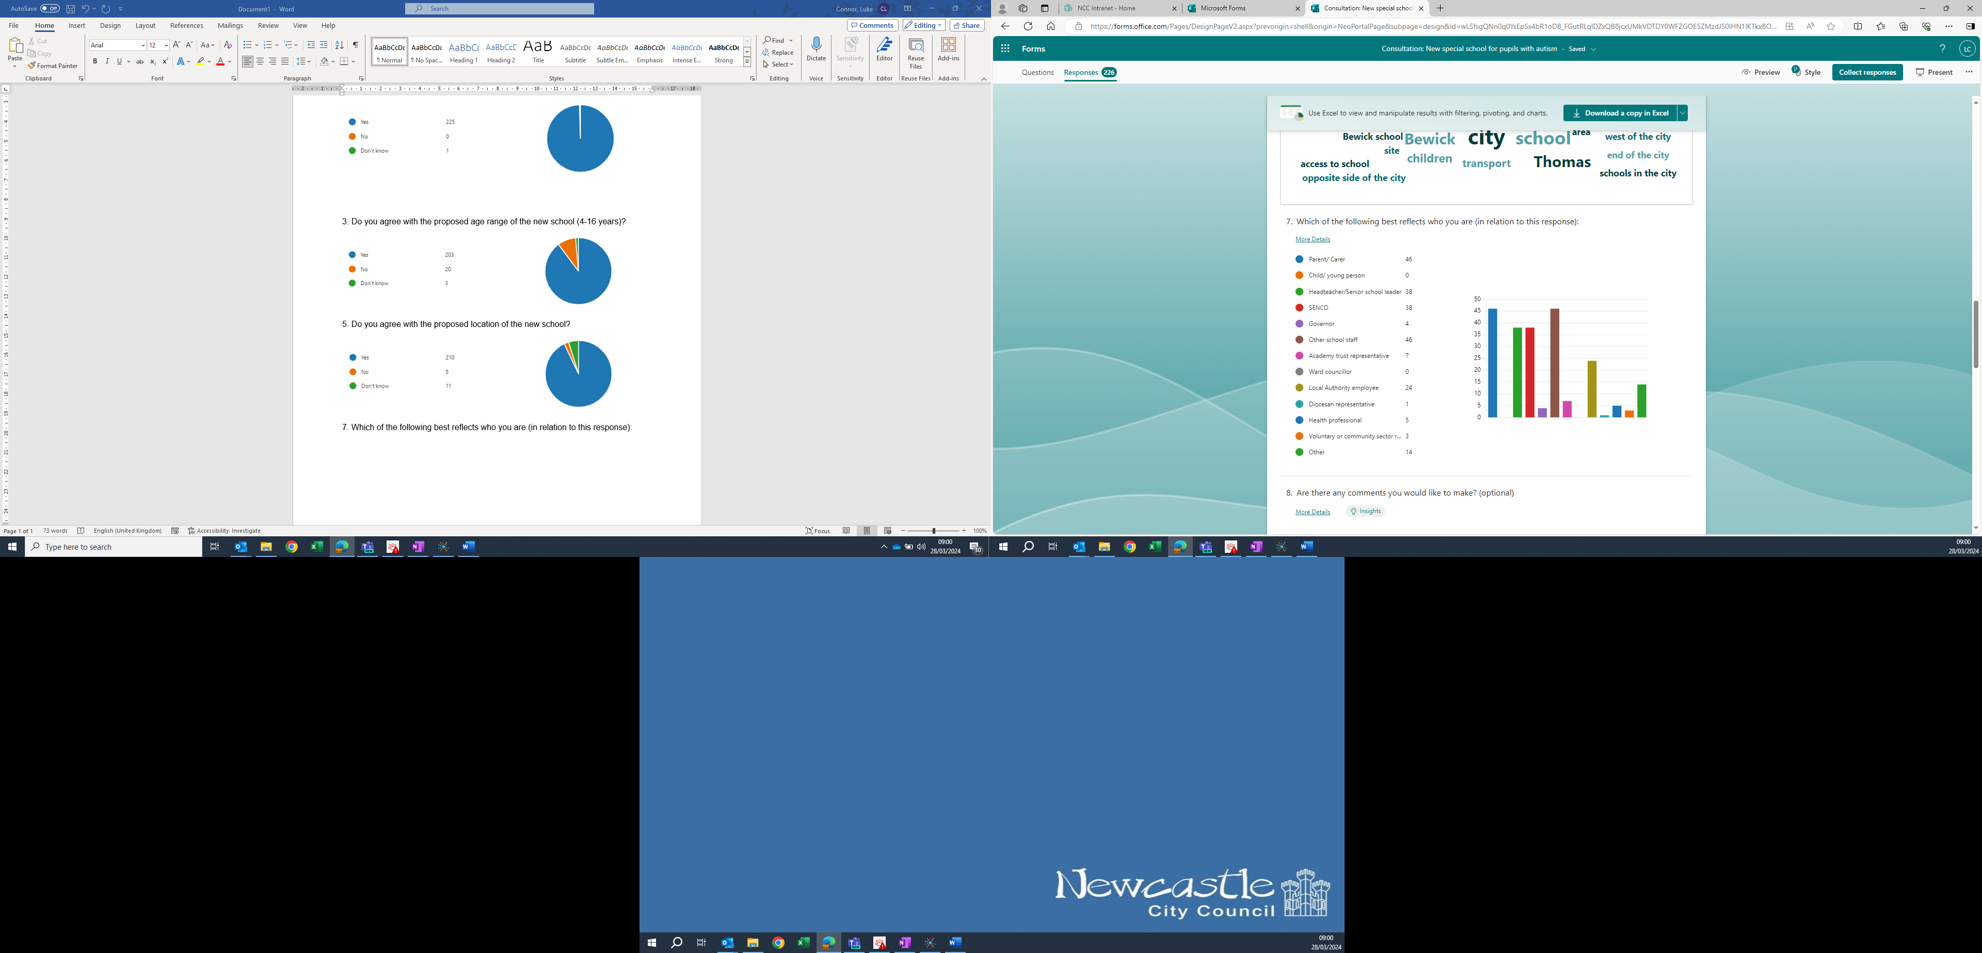

Stakeholders were asked to indicate whether they agreed, disagreed or didn’t know in relation to:

* the proposal to establish a new special school in Newcastle for children and young people with autism
* the proposed age range of the new school (4-16 years)
* the proposed location of the new school

Respondents were also invited to make comments relating to the above proposals, as well as recording any further comments, queries or concerns they had in general.

**Consultation results: New special school for pupils with autism**

1. Do you agree with the proposal to establish a new special school in Newcastle for children and young people with autism?

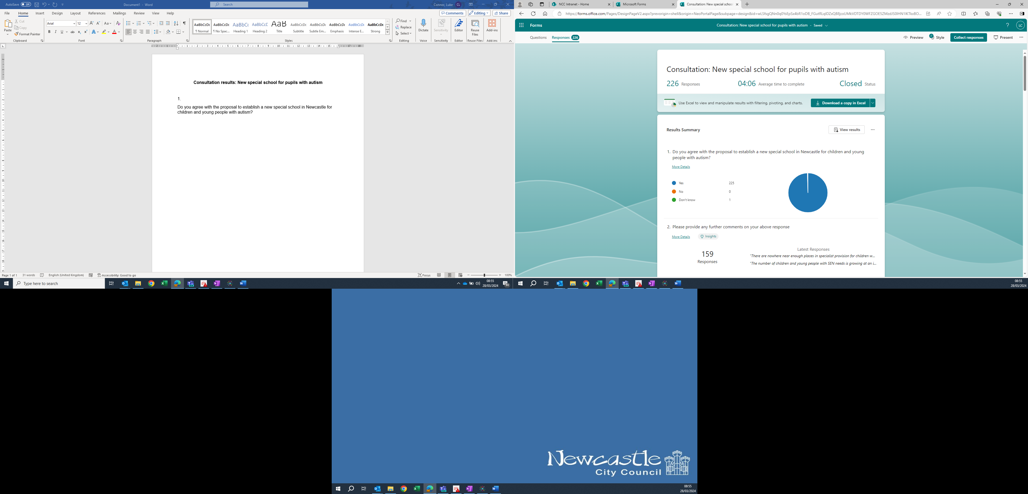

2. Please provide any further comments on your above response

Total number of comments: 157

Summary of comments:

* General supportive statement and reasons why a new school is needed: 137
* Culture change in mainstream schools to support neurodiversity is also needed: 4
* Will this be sufficient places to meet needs: 3
* More diagnostic capacity needs to be developed in Newcastle: 1
* New school needs to meet needs of academically able children with autism: 1
* Query – is there enough money for this project: 1
* Other comments about current provision and services: 10

3. Do you agree with the proposed age range of the new school (4-16 years)?

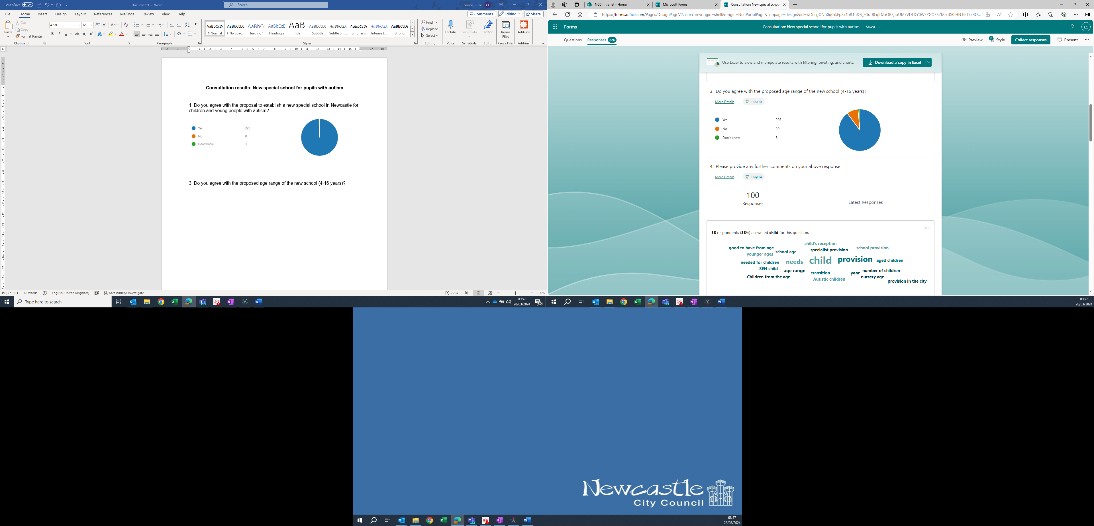

4. Please provide any further comments on your above response

Total number of comments: 98

* General supportive statement and comments: 30
* Provision for nursery age range is also required: 18
* Positive comments on all-through provision to reduce difficult transitions: 17
* Need to also include post-16 provision: 26
* Need to consider how to manage different primary/secondary age-ranges and needs on same site: 2
* Other comments about current provision and services: 5

5. Do you agree with the proposed location of the new school?

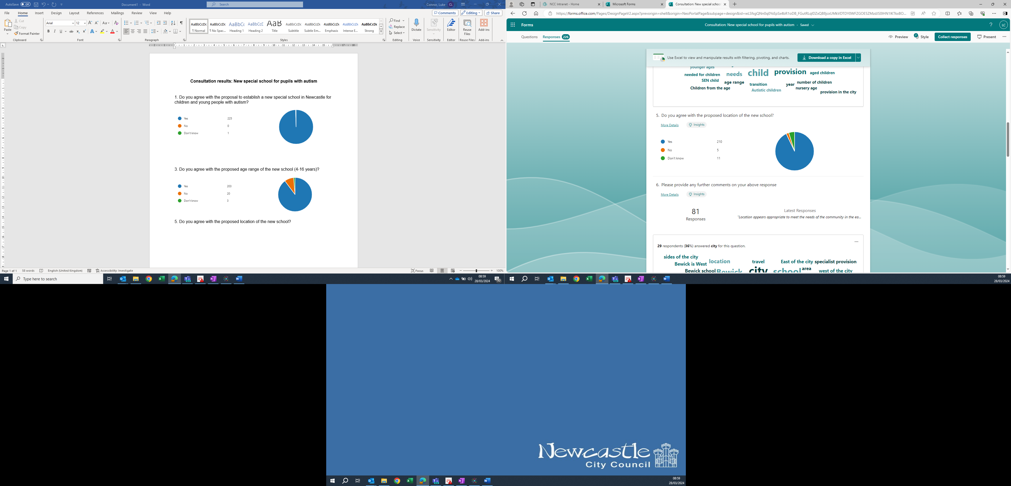

6. Please provide any further comments on your above response

Total number of comments: 68

* General supportive statement and comments: 59
* Other alternative locations suggested:
  + Kenton/Gosforth/Jesmond: 2
  + Centre of Newcastle: 2
  + Newburn: 1
  + West end: 1
* Other comments about current provision and services: 3

8. Are there any comments you would like to make?

Total number of comments: 57

* General supportive statement and comments: 22
* Will this provide enough places for future need (expansion): 3
* Mainstream education settings need to understand and support autism too: 2
* Provision for children with multiple needs is needed: 5
* Post-16 needs to be addressed: 2
* Support for more able autistic children needed: 2
* Adaptation of mainstream environments need to be developed: 1
* Is there enough (capital) funding for this project: 1
* Travel training should be provided to help preparation for adulthood: 1
* Develop links to UTC around technology specialism: 1
* Other comments about current provision and services: 17